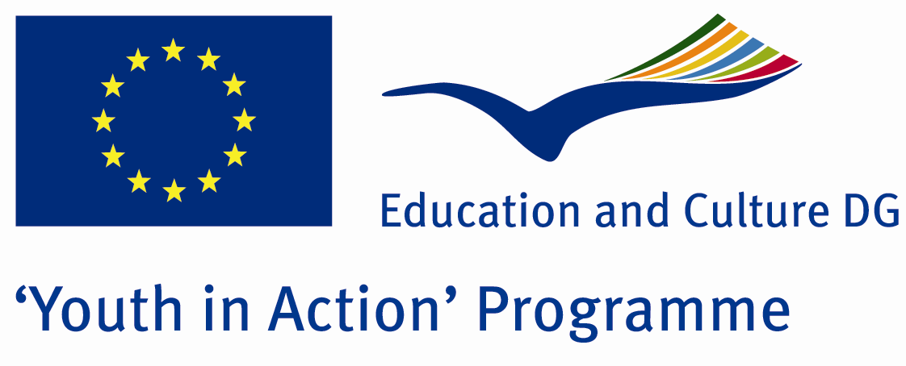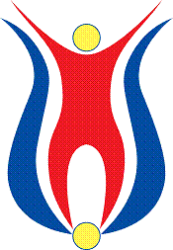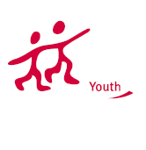

Action 1.1
Project Summary;

You know there are 4 element in the nature.These elements are symbols of different things.Here in this project we ll give these beautifull meaning to the participants.ıf you want please join us.
Project Title; 4 elments
Date and Venue ; 22-29 April,2012
Place: Kütahya.

Target Group ; Municipalities, City Councils and Non-Governmental organizations,
youth groups,culture and art groups,e.t.c

Participants ; 5 people from each country (over 18 -25 ). Totally 8 countries.

Conditions ; Accommodation, board and programme costs will be financed through European Commission Youth in Action Programme . Travel costs will be reimbursed in 70% (APEX Tarrifs). Organizations from all 27 EU member countries plus Liechtenstein , Norway and Iceland are eligible to take part.

Working language: English

Organisator group: Sevgi ve Dostluk Grubu

How to apply: If you are interested, please send your Part III forms to
by e-mail please (in word file). Scan Part3 format is enough for application.(Fulfilled Part III which you can find in the attachment, of course signed and stamped) ..

Contact e-mail: sevgi.dostlukgrubu@gmail.com

